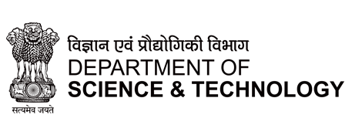

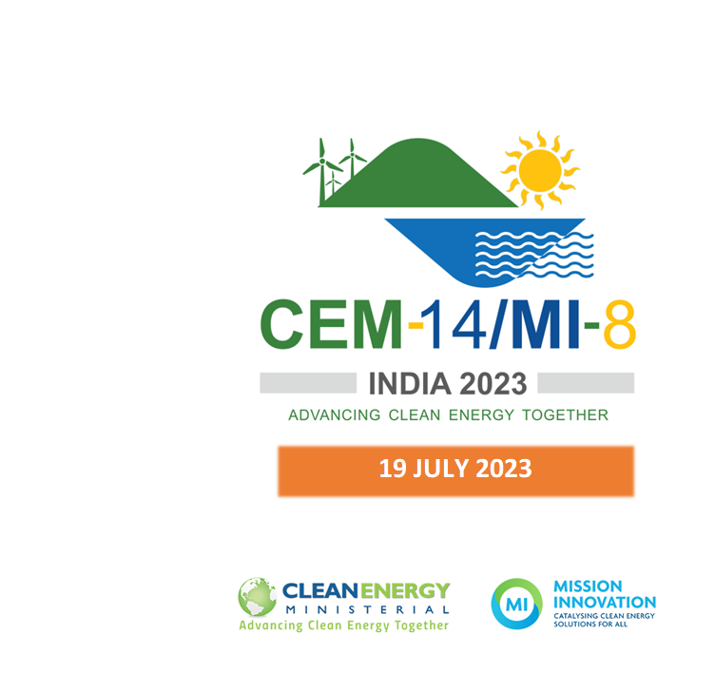

The transition towards low-carbon affordable heating and cooling solutions - The way ahead

Innovation Community on Affordable Heating and Cooling of Buildings

**Event Summary**

The transition towards low-carbon affordable heating and cooling solutions - The way ahead

Innovation Community on Affordable Heating and Cooling of Buildings

The 14th Clean Energy Ministerial and 8th Mission Innovation meeting (CEM14/MI-8) was held in Goa, India, from 19th to 22nd July 2023. This was planned alongside the G20 Energy Transitions Ministerial Meeting. The CEM and MI meetings brought together diverse stakeholders, including governments, international organizations, private sector representatives, academia, innovators, civil society, and policymakers. India, alongside the UK and the European Commission as Co-leads of the Innovation community, organized a side event titled 'The transition towards low-carbon affordable heating and cooling solutions - The way ahead.'

The event focused on exploring pathways and disruptive technologies for sustainable heating and cooling of buildings, identifying synergies with other missions, and fostering international collaboration for potential programs. Two-panel sessions discussed current innovation activities, achievements, and future areas of research and deployment for sustainable cooling technologies, as well as cross-cutting research priorities and solutions in heating and cooling sectors.

The event gathered experts, researchers, and industry leaders to discuss low-carbon cooling technologies. The session highlighted DST's R&D initiatives, the Global Cooling Prize (GCP) insights, and industry-driven efforts. A panel discussion explored synergies with MI Missions, addressing extreme heat, grid-connected buildings, and industry collaboration. The event emphasized the importance of international cooperation in driving sustainable cooling solutions, promising to pave the way for a greener and more efficient future.

The session commenced with a warm welcome by Dr Anita Gupta from DST India, followed by an overview of the session and AHCB activities by Dr Anna Stephenson from the Department of Energy Security and Net Zero in the UK and an address by Eleanor Webster, Head of Secretariat, Mission Innovation.

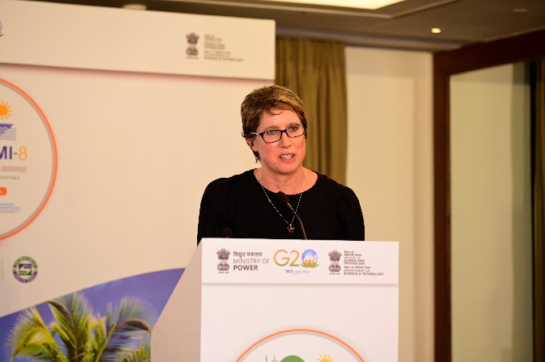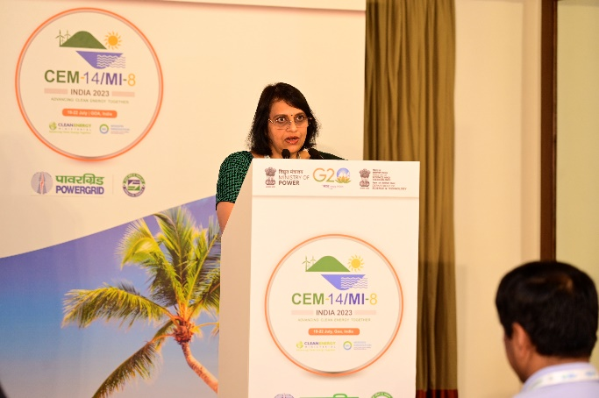

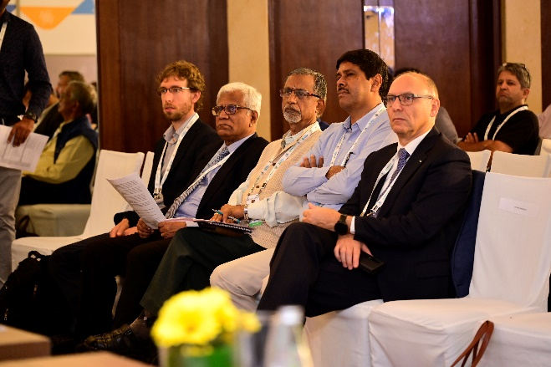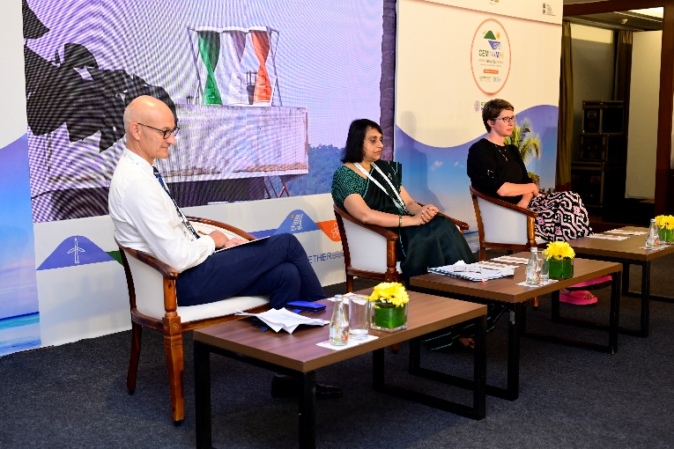

The event had two sessions of panel discussions-

**Session I:** The first session focused on MI collaborative innovation for low-carbon cooling in India and was chaired by Dr Sukumar Devotta, Former Director NEERI Nagpur, India. Panellists were- ISHRAE, RAMA, Danfoss, Daikin, Bluestar, RMI, Voltas, S&S Design startup, and Clean Cooling Collaborative. Presenters during this session shared insights into industry-driven initiatives for low carbon cooling. The following points were discussed.

* Learnings of GCP demonstrated the development of super-efficient air conditioner. As a next step to commercialise, a global cooling efficiency accelerator (improvement of testing standards and improvement of metrics, support the manufacturing ecosystem, data collection, market creation and Awareness & outreach) is spearheaded by RMI.
* Cooling devices with zero GWP refrigerants.
* Waste water to portable water from cooling devices.
* Super-efficient ACs contribute to a cumulative emission reduction of 70 Gigatonnes by 2050, and 16 Gigatonnes in India alone.
* Upgrades and new standards and codes on Building Energy Efficiency
* Potential energy efficiency strategies such as microchannel heat exchangers and coating to reduce corrosion.
* Integrated Grid control- integrate grid protocol with air conditioner operations and control
* Rapid cooler with rapid cooling technology for beverages.
* Need for a balance between standardisation and customisation.
* Digitising systems, eliminating waste and reducing water in cooling.

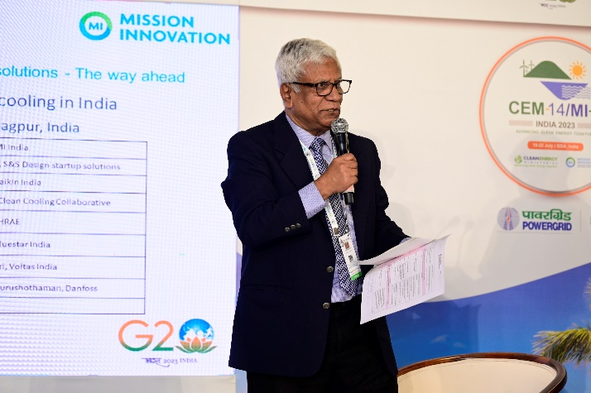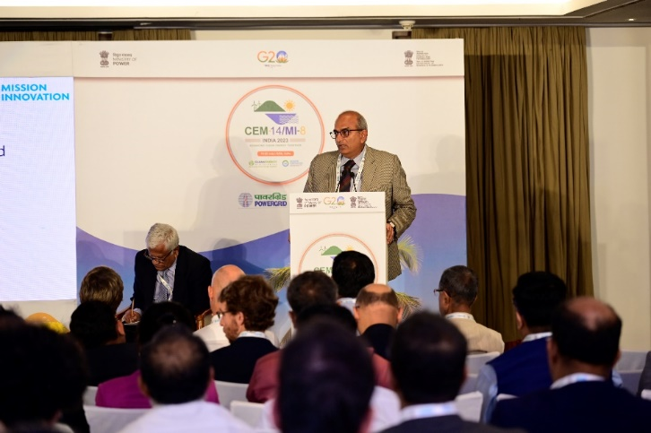

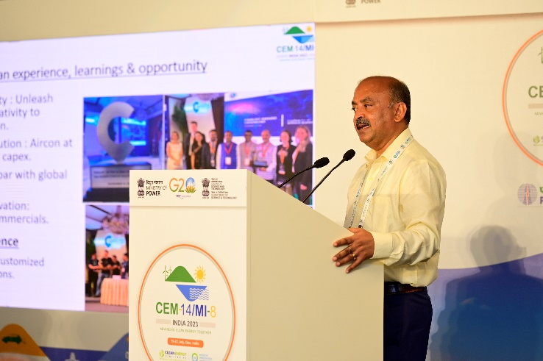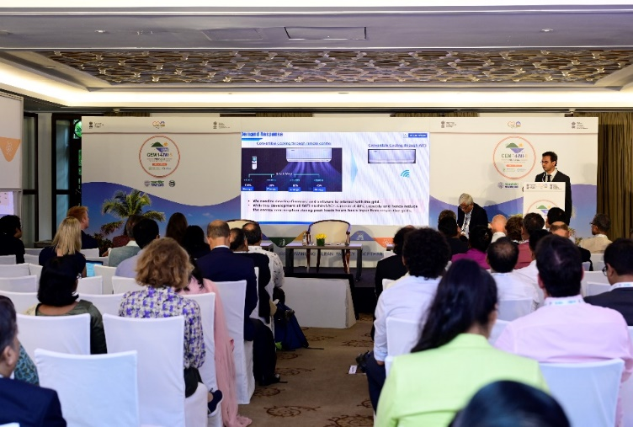

**Session II:** The second session moderated by Dr Graeme Maidment from the UK explored collaboration and synergies with the MI (Mission Innovation) Missions. Panelists from Cool Coalition, Urban Transition Mission, Green Powered Future Mission, UNEP and TICR UK shared the stage. Topics such as extreme heat and innovation within cities, grid-connected buildings, and opportunities for collaboration under the Industry Mission were discussed. The following points were discussed,

* Decarbonisation and securing circularity
* Significance of cooling – which is the key priority of 8 Countries involved in the Urban Transition Mission
* Impact of cooling on power systems, climate impact, productivity and social equity
* Heat Resilient Urban Planning and nature based solutions
* Digitalisation of building systems

Mr Brian Dean emphasised the need for local production to reduce costs and ability to bring flexibility by storing energy.

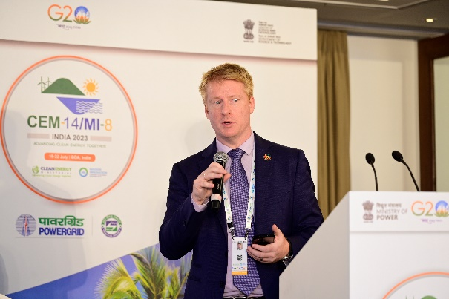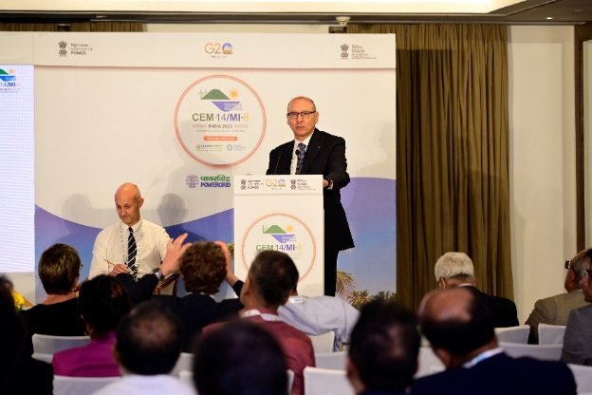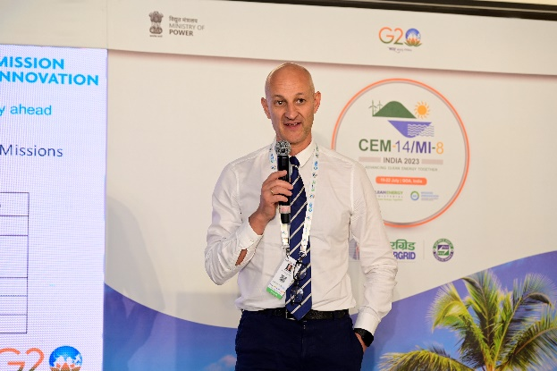

The event concluded with a closing remark by Dr Nagesh Iyer from IIT Dharwad, India, who highlighted the significance of such collaborative efforts in driving innovation for low-carbon cooling solutions. He summarized the following short-term goals.

* Hand holding regulatory mechanisms and setting of standards
* Automation and Integration of technologies for data collection
* Support the development of smart controls and protocol for grid integration.
* Scalable low cooling technologies

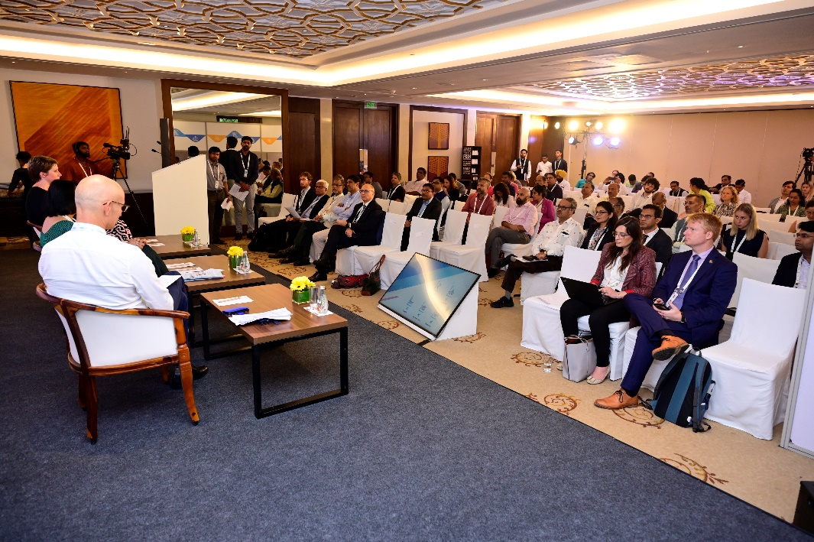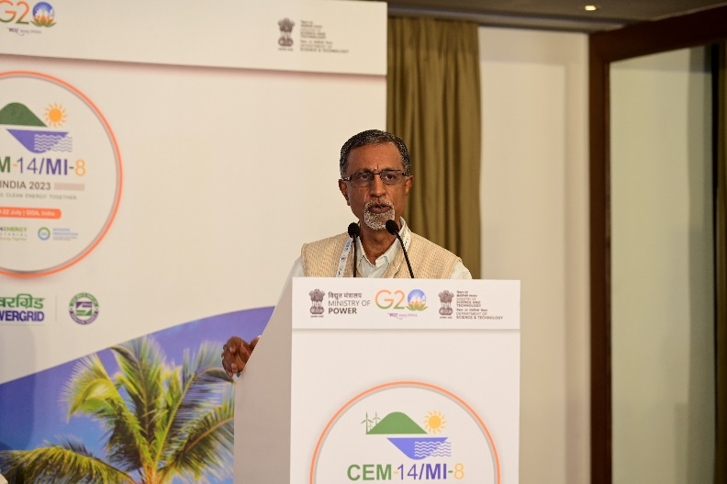

The meeting concluded with a note of thanks from the co-leads and a statement of commitment to the ongoing endeavours in sustainable and affordable heating and cooling of buildings.